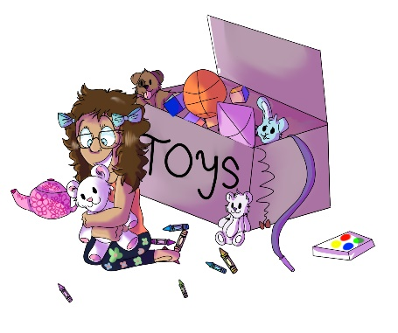
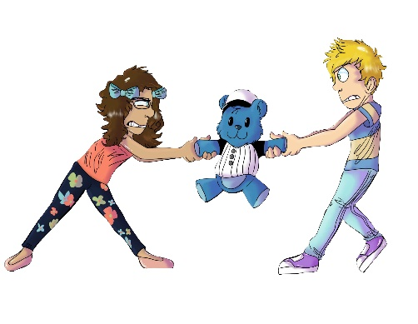
House 123
Erinn NoSharin
Answers

- In House 123, what is Erinn NoSharin not good at doing?
- Baking cupcakes
- Sharing
- Riding her bicycle

- When Erinn stops sharing her toys with her friends, what do they do?
- Her friends get upset
- Her friends stop playing with her
- Both a. and b.

- After Erinn loses her friends, which of the following fun things can she still do?
- Win on a board game
- Race on her bicycle
- Play alone with her toys

- Who teaches Erinn that she will not have friends if she does not share?
- Judge Boom
- May-Lin Snobberfin
- Obie Overmean

- At the end of House 123, what does Erinn decide to do?
- Continue to play alone with her toys and not have any friends
- Share her toys and have more fun playing with friends
- Neither a. or b.
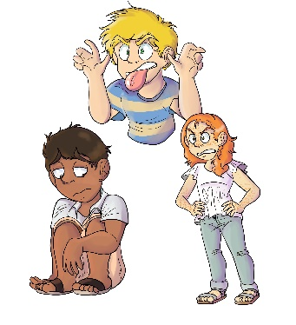
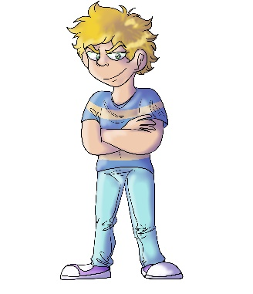
House 223
Obie Overmean
Answers

- In House 223, what is Obie Overmean known for doing?
- Being mean and bullying others
- Getting good grades and being good at sports
- Both a. and b.

- Why did Obie bully the BB Boulevard children?
- He did it for fun and to get some good laughs
- Because others are mean to him
- He doesn’t get enough attention from his friends

- What do Obie’s coach and teacher do when they see him bully others?
- They give him a trophy and certificate for high scores and grades
- They kick him off of the team and give him a bad report card
- They don’t care how he treats the other kids.

- What do the BB Boulevard children do after Obie bullies them?
- They do whatever he asks them to do
- They no longer play with him, sit with him, or invite him to parties
- Neither a. or b.

- At the end of House 223, does Obie get his friends back?
- No, because he never told his friends he was sorry
- No, because he thinks its okay to bully others for laughs
- Yes, because he told his friends he was sorry and stopped being mean
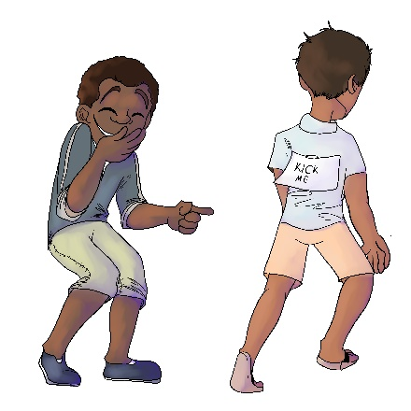
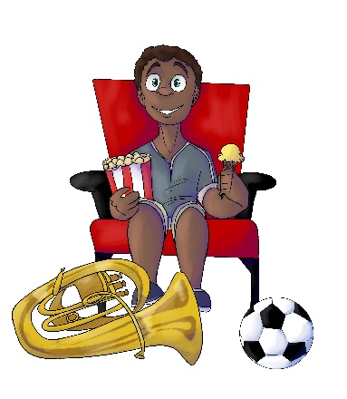
House 323
Shamus Giggleback
Answers

- In House 323, who is Shamus’ best friend?
- Raji Rudemore
- Obie Overmean
- Erinn NoSharin

- What does Shamus do that upsets his friends?
- He laughs when he sees them getting bullied by other kids
- He does not warn them when he knows they could get hurt
- Both a. and b.

- Is Shamus a bully?
- Yes, he is a “background bully.” He hurt his friends even more when he laughed and did nothing to help.
- No, because he is not the one actually causing the harm
- No, because he is just laughing like everyone else

- When Shamus laughed and did not help his friends, what happened?
- Blayre got sick, Raji got scared, and Erinn could not face her friends.
- Nothing. They forgot all about it.
- Neither a. or b.

- What should Shamus do when he sees someone getting bullied?
- If he knows who did it, he should keep it to himself
- He should stop a bully, report a bully, or warn a friend in need
- He should walk away and not laugh
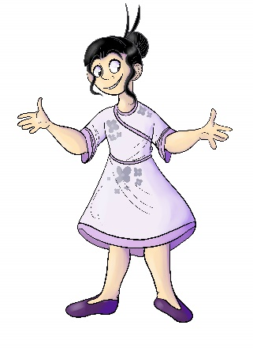
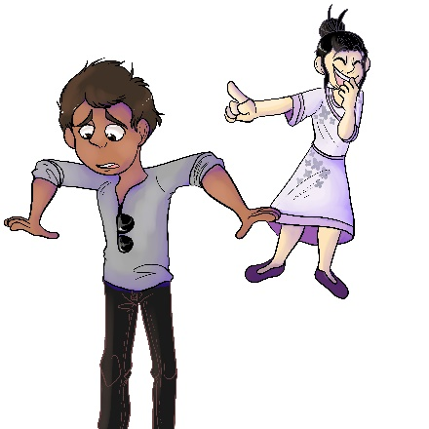
House 423
May-Lin Snobberfin

- What instrument does May-Lin play?
- Violin
- Flute
- Piano

- How does May-Lin hurt Erinn’s feelings?
- She doesn’t go to Erinn’s birthday party
- She tells Erinn the watch her mother gave her is “ugly”
- Neither a. or b.

- Why does May-Lin choose Obie instead of Blayre as her school project partner?
- Obie is more popular
- Someone else already chose Blayre
- She thinks Blayre will not have the time to meet to complete it

- Why does May-Lin tease Raji about his new outfit?
- He told her he got it from a discount store
- He is wearing his shirt inside out
- Both a. and b.

- Why did May-Lin suddenly start talking to Shamus when she never talked to him before?
- She thought he did not like her
- She learned his uncle is someone famous
- She was too shy
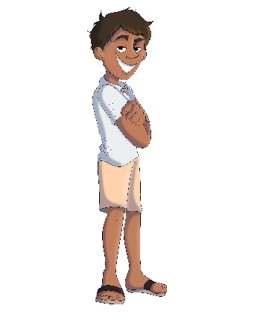
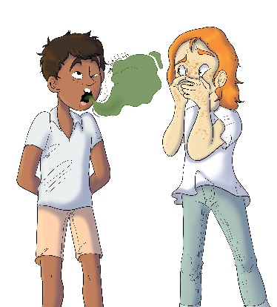
House 523
Raji Rudemore
Answers

- What sport does Raji play?
- Soccer
- Tennis
- Baseball

- How did Judge Boom teach Raji that his rudeness is hurtful to his friends?
- She magically put him into his friends’ shoes
- She grounded him for a week
- She told his parents

- How was Raji rude to Blayre?
- He burped in her face without saying excuse me
- He bumped into her and did not check to see if she was okay
- Both a. and b.

- How was Raji rude to his teacher and classmates?
- He spilled juice on his homework
- He got sick and had to miss class
- He played on his device while his teacher was teaching

- What did Raji learn to be a better friend?
- He learned how to respect his friends and their feelings
- He learned what flavor ice cream they all like
- He learned how to spell their names
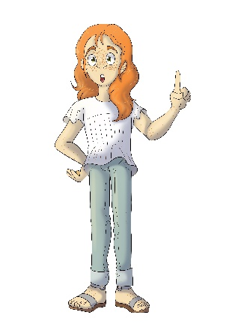
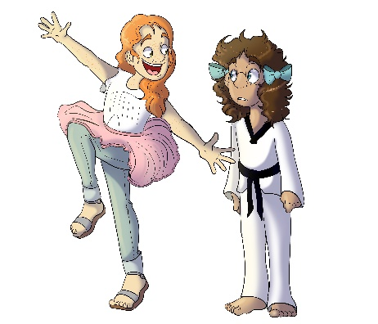
House 623
Blayre Ordinaire

- Why does Blayre think Erinn should not do karate?
- She thinks Erinn could get hurt
- She thinks girls should not do karate
- She thinks karate will be too hard

- What two holidays is Blayre surprised Raji celebrates?
- Hanukkah and Diwali
- Easter and Halloween
- Ramadan and Thanksgiving

- Why is Obie and his little brother being raised by his grandmother?
- His parents live right next door and work many hours
- His parents are serving overseas in the military
- Neither a. or b.

- Why did Blayre think Shay-Lin could not go to the movies?
- She mistakenly thought Shay-Lin could not do much because she wears leg braces.
- She thinks Shay-Lin is too young to watch the movie
- He played

- What did Blayre learn about Ethiopian food from Shamus?
- He likes to cook with his mom
- It is not easy to make
- If you try something new, you might actually like it

