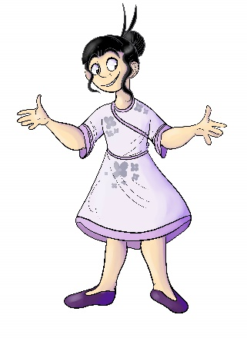
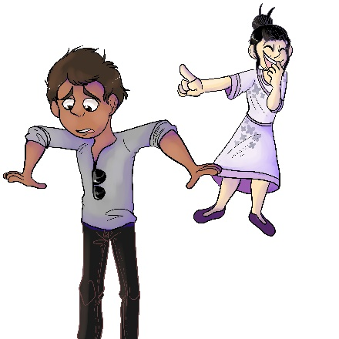
House 423
May-Lin Snobberfin

- What instrument does May-Lin play?
- Violin
- Flute
- Piano

- How does May-Lin hurt Erinn’s feelings?
- She doesn’t go to Erinn’s birthday party
- She tells Erinn the watch her mother gave her is “ugly”
- Neither a. or b.

- Why does May-Lin choose Obie instead of Blayre as her school project partner?
- Obie is more popular
- Someone else already chose Blayre
- She thinks Blayre will not have the time to meet to complete it

- Why does May-Lin tease Raji about his new outfit?
- He told her he got it from a discount store
- He is wearing his shirt inside out
- Both a. and b.

- Why did May-Lin suddenly start talking to Shamus when she never talked to him before?
- She thought he did not like her
- She learned his uncle is someone famous
- She was too shy

