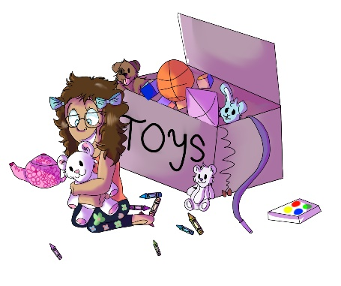
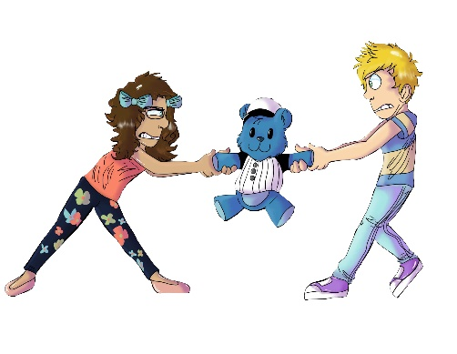
House 123
Erinn NoSharin

- In House 123, what is Erinn NoSharin not good at doing?
- Baking cupcakes
- Sharing
- Riding her bicycle

- When Erinn stops sharing her toys with her friends, what do they do?
- Her friends get upset
- Her friends stop playing with her
- Both a. and b.

- After Erinn loses her friends, which of the following fun things can she still do?
- Win on a board game
- Race on her bicycle
- Play alone with her toys

- Who teaches Erinn that she will not have friends if she does not share?
- Judge Boom
- May-Lin Snobberfin
- Obie Overmean

- At the end of House 123, what does Erinn decide to do?
- Continue to play alone with her toys and not have any friends
- Share her toys and have more fun playing with friends
- Neither a. or b.

