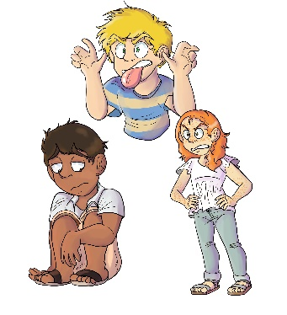
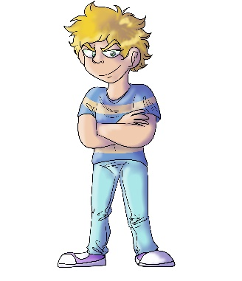
House 223
Obie Overmean

- In House 223, what is Obie Overmean known for doing?
- Being mean and bullying others
- Getting good grades and being good at sports
- Both a. and b.

- Why did Obie bully the BB Boulevard children?
- He did it for fun and to get some good laughs
- Because others are mean to him
- He doesn’t get enough attention from his friends

- What do Obie’s coach and teacher do when they see him bully others?
- They give him a trophy and certificate for high scores and grades
- They kick him off of the team and give him a bad report card
- They don’t care how he treats the other kids.

- What do the BB Boulevard children do after Obie bullies them?
- They do whatever he asks them to do
- They no longer play with him, sit with him, or invite him to parties
- Neither a. or b.

- At the end of House 223, does Obie get his friends back?
- No, because he never told his friends he was sorry
- No, because he thinks its okay to bully others for laughs
- Yes, because he told his friends he was sorry and stopped being mean

