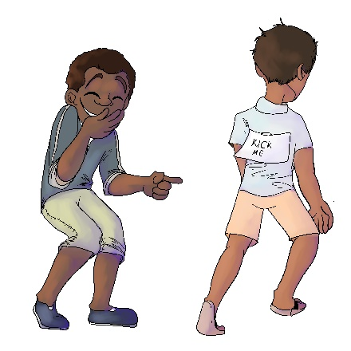
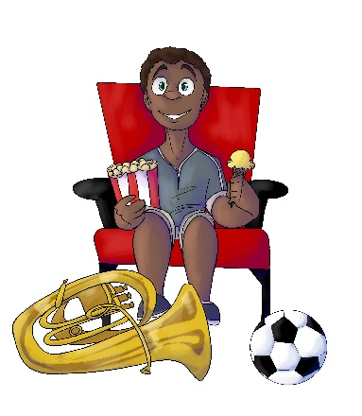
House 323
Shamus Giggleback

- In House 323, who is Shamus’ best friend?
- Raji Rudemore
- Obie Overmean
- Erinn NoSharin

- What does Shamus do that upsets his friends?
- He laughs when he sees them getting bullied by other kids
- He does not warn them when he knows they could get hurt
- Both a. and b.

- Is Shamus a bully?
- Yes, he is a “background bully.” He hurt his friends even more when he laughed and did nothing to help.
- No, because he is not the one actually causing the harm
- No, because he is just laughing like everyone else

- When Shamus laughed and did not help his friends, what happened?
- Blayre got sick, Raji got scared, and Erinn could not face her friends.
- Nothing. They forgot all about it.
- Neither a. or b.

- What should Shamus do when he sees someone getting bullied?
- If he knows who did it, he should keep it to himself
- He should stop a bully, report a bully, or warn a friend in need
- He should walk away and not laugh

