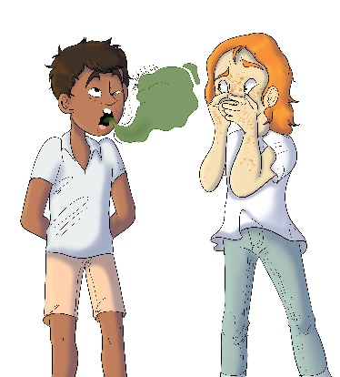
House 523
Raji Rudemore

- What sport does Raji play?
- Soccer
- Tennis
- Baseball

- How did Judge Boom teach Raji that his rudeness is hurtful to his friends?
- She magically put him into his friends’ shoes
- She grounded him for a week
- She told his parents

- How was Raji rude to Blayre?
- He burped in her face without saying excuse me
- He bumped into her and did not check to see if she was okay
- Both a. and b.

- How was Raji rude to his teacher and classmates?
- He spilled juice on his homework
- He got sick and had to miss class
- He played on his device while his teacher was teaching

- What did Raji learn to be a better friend?
- He learned how to respect his friends and their feelings
- He learned what flavor ice cream they all like
- He learned how to spell their names

