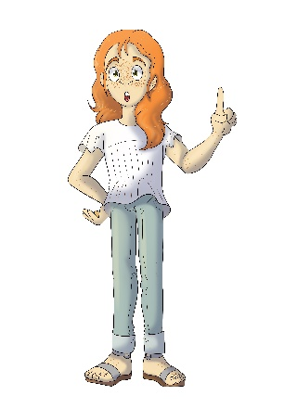
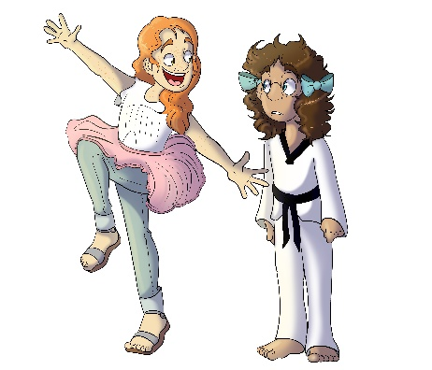
House 623
Blayre Ordinaire

- Why does Blayre think Erinn should not do karate?
- She thinks Erinn could get hurt
- She thinks girls should not do karate
- She thinks karate will be too hard

- What two holidays is Blayre surprised Raji celebrates?
- Hanukkah and Diwali
- Easter and Halloween
- Ramadan and Thanksgiving

- Why is Obie and his little brother being raised by his grandmother?
- His parents live right next door and work many hours
- His parents are serving overseas in the military
- Neither a. or b.

- Why did Blayre think Shay-Lin could not go to the movies?
- She mistakenly thought Shay-Lin could not do much because she wears leg braces.
- She thought Shay-Lin would be too young to watch the movie
- She only wanted to go with her sister May-Lin.

- What did Blayre learn about Ethiopian food from Shamus?
- He likes to cook with his mom
- It is not easy to make
- If you try something new, you might actually like it

